IMAGE PROCESSING · FINAL PROJECT  Every Coin Counts  Counting coins on a textured pad with classical image processing | Author  Yulia Rapana  Lecturer  Dr. Cornel Lustig  Holon institute of Technology HIT · summer 2026

89.6%  recall  294 of 328 coins found | 88.3%  precision  294 of 333 detections were coins | 39 / 34  false / missed  FP non-coins · FN missed coins | 12/26  exact counts  only 7 with no mistake at all

The problem  People count coins at a glance; a computer sees only pixels. The phone photos add three traps: a white pad full of folds and seams, dark or motion-blurred shots, and buttons the size of a coin mixed in.  Question Can fixed classical rules, with no training, count only the coins under these conditions?  Data 26 photos · 328 coins · 12 buttons, hand-counted and split into clean, noisy (dark / blurred) and damaged (piles, cut coins, buttons). Then every circle the program drew was checked: coin (TP), not a coin (FP) or a coin without a circle (FN). |  | The pipeline  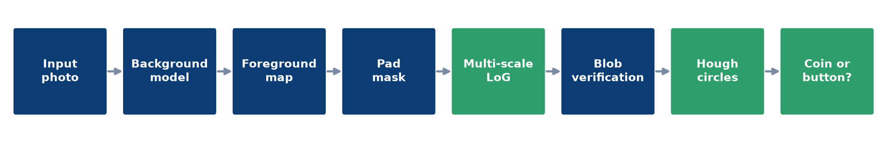  ■ Background: a huge median filter models pad and light; each pixel gets a Lab “difference from background” score.  ■ Blobs: multi-scale Laplacian of Gaussian finds round, coin-sized peaks.  ■ Folds: a Hessian test rejects ridges; a grayscale opening removes thin seams.  ■ Touching coins: Hough circles split what LoG merges.  ■ Buttons: black-hat reveals sewing holes; blue or pink objects are never coins.

From photo to count
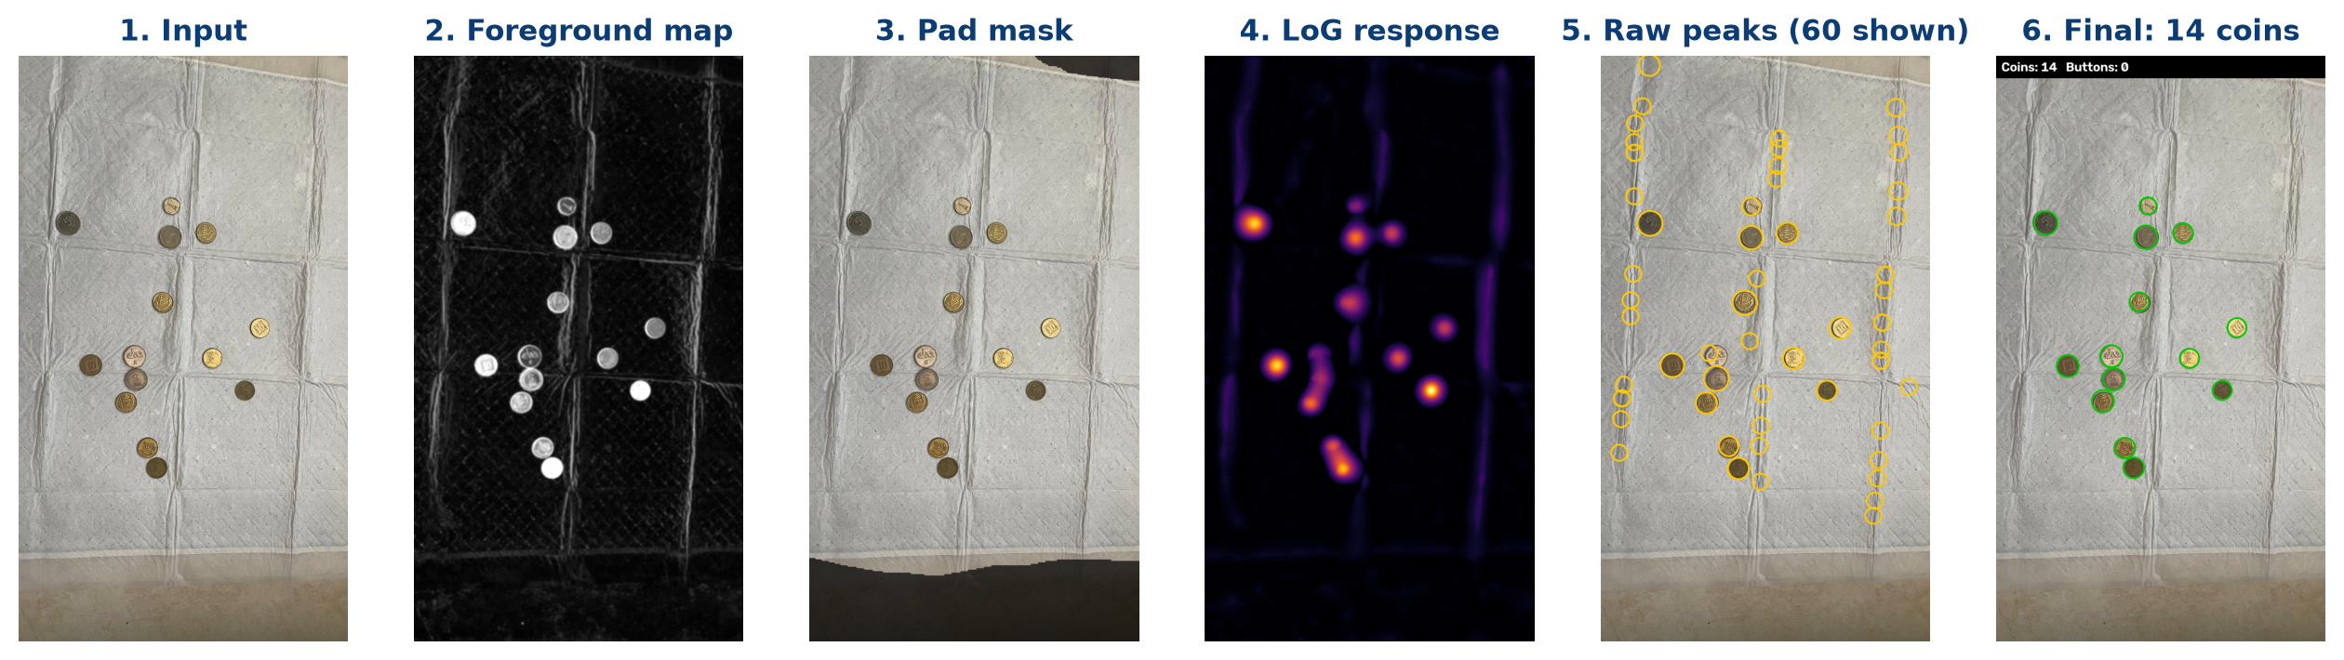
Input → foreground map → pad mask → LoG response → raw peaks (mostly folds) → 14 coins after verification.
Results  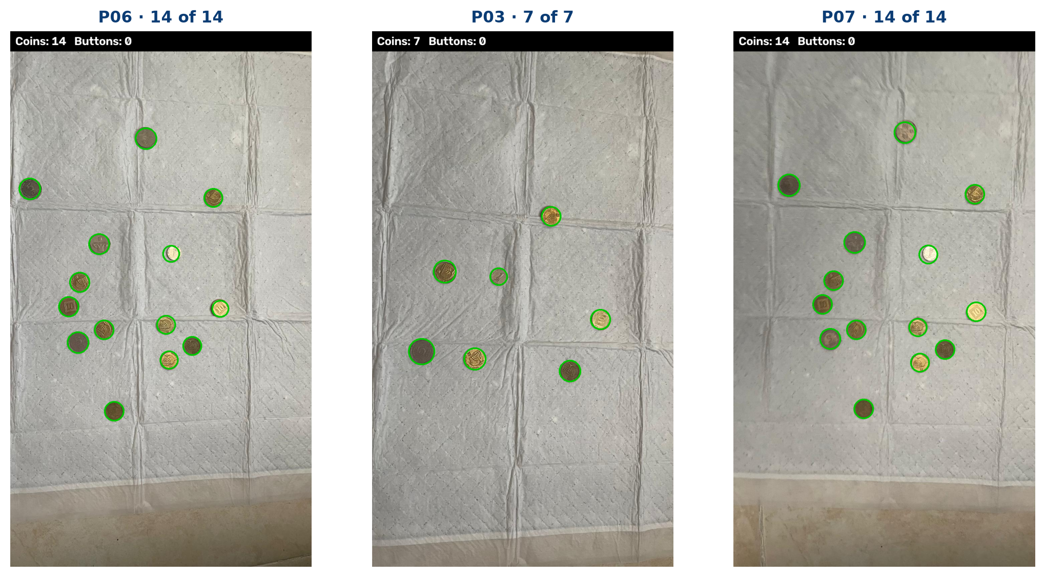  Three clean photos with no mistake.  Clean photos: all 98 coins found, 1 false detection. Dark photos add false coins; piles and the frame hide real ones. |  | What was mistaken for a coin  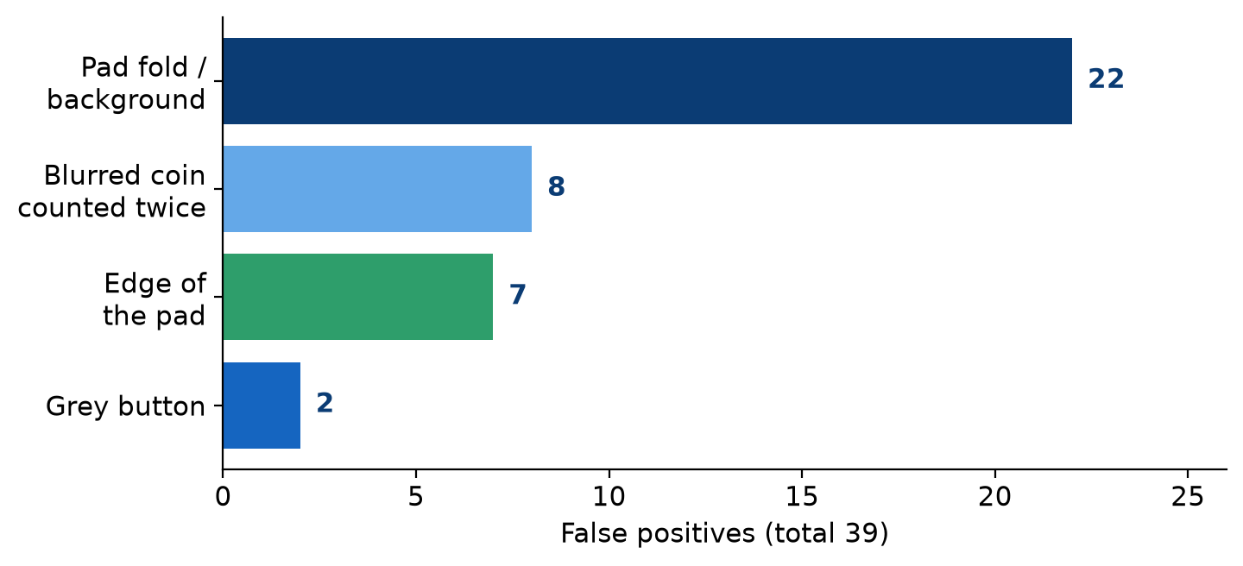  Causes of the 39 false positives.  12 photos got the exact total, but in 5 of them a false coin and a missed coin cancelled out. |  | Round, but not a coin  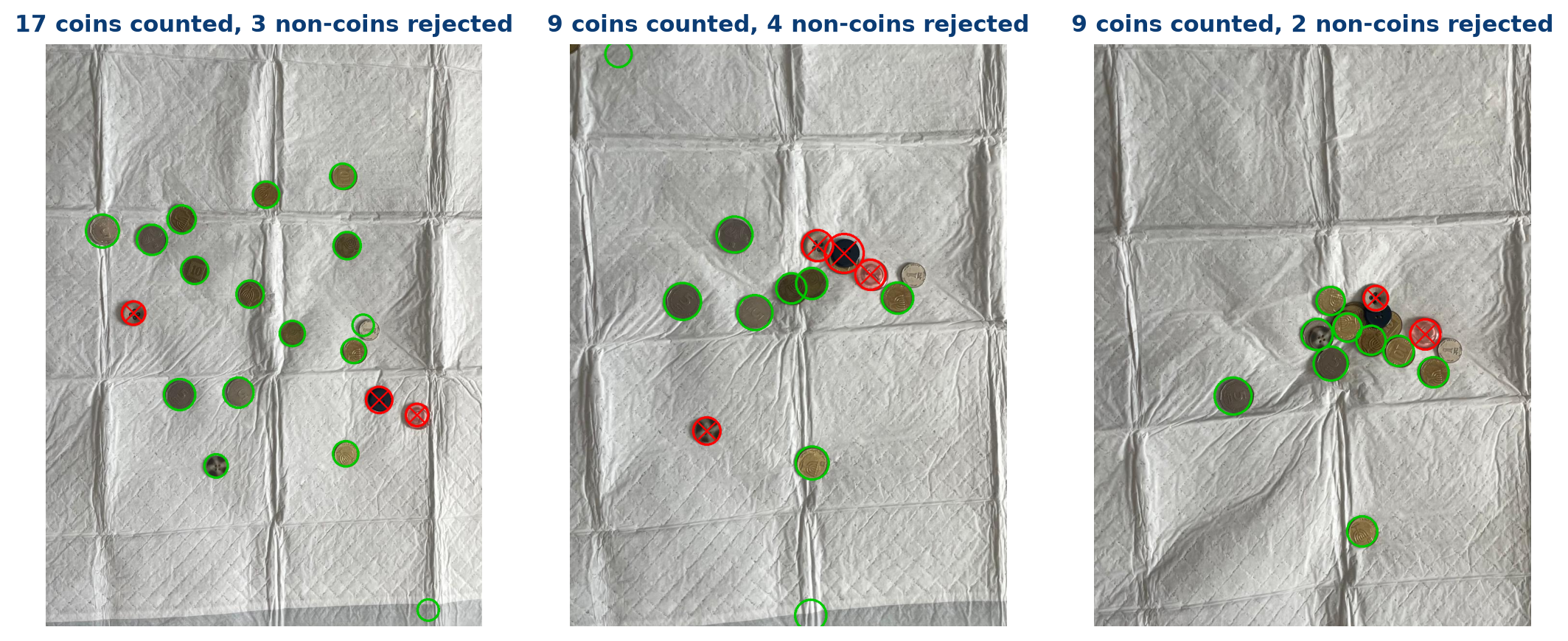  Red X = button, not counted.  9 of 12 buttons rejected by colour or sewing holes (black-hat); 2 grey buttons passed as coins.

Conclusion  Classical tools alone found 89.6% of the coins with 88.3% precision and rejected 9 of 12 buttons. Checking every circle, not just the total, showed where and why the machine fails. | Limitations  Motion blur splits a coin into several blobs (22 counted vs 12). Dense piles hide coins, coins cut by the frame are half-circles, and a grey button without visible holes looks like a coin. | Next steps  Merge detections along the blur direction, drop the white hem from the pad mask, fit partial circles at the image border, and use rim colour to catch grey buttons.

